The Islamic University of Gaza  Faculty of Information Technology  Department of Computer Science |  | Fall Semester 2025–2026  Programming 1 – Lab  Instructor: Aya N. Alharazin
What Is Programming?
is the process of giving instructions to a computer so it can do what you want.
What Are Programming Languages?
A programming language is a special language that we use to tell the computer what to do.
Computers do not understand Arabic or English — they only understand binary (0s and 1s).
So we use programming languages as a bridge to communicate with the computer in a way that is easier for humans.
Types of Programming Languages
High-Level Language
A high-level programming language is a language that is easy for humans to read, write, and understand.
It is close to human language and far from machine language (0s and 1s) like java , c++ ,c#.
Low-Level Languages
Languages that are close to the machine (computer hardware).
We will use Java Programming language
How a Java Program Is Translated

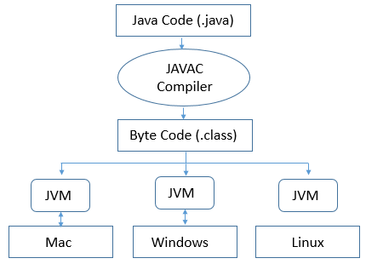
What Is JDK?
JDK stands for Java Development Kit.
It is a package of tools that you need to write, compile, and run Java programs.
What’s Inside the JDK?
JVM , Java Compiler (javac) , JRE (Java Runtime Environment) , Tools for developers
What Is an IDE?
IDE stands for Integrated Development Environment.
It is a software tool that programmers use to write, edit, run, and debug code — all in one place.
We’ll use netbeans
- We need to download jdk and netbeans

